

# ENVIRONMENTAL MONITORING OF EMPEROR PENGUIN COLONIES

# capa_cyclone.jpg

OCTOBER 2022

By Romao, M., Pires, L. B. M.



# ENVIRONMENTAL MONITORING OF EMPEROR PENGUIN COLONIES

This newsletter monitors the climatic conditions of the Snow Hill emperor penguin colonies, located north of the Antarctic Peninsula and Cape Washington located in the Ross Sea.Emperor penguins are very susceptible to sudden variations in the climate, especially their young that cannot be exposed to rain and the sea before their feathers are fully formed on their entire body.The early breaking or breaking of the fast ice, where the eggs of these birds are hatched, can endanger the litter for an entire year, as well as the storms that can isolate the young from the group, especially during the winter.Monitoring the meteorological conditions of these colonies can indicate how vulnerable these birds are to the climatic changes of this extremely sensitive and fragile environment.

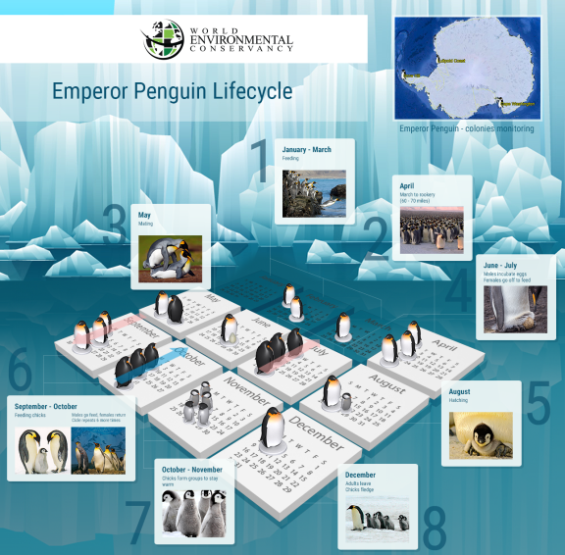

The Emperor penguin endures one of the harshest breeding cycles of any animal. It breeds during winter (beginning in early April) in one of the coldest places on Earth. Once it leaves the frigid water, it hikes on the Antarctic fast ice for up to three days, traveling up to seventy miles (110 km) before it reaches its colony. Unlike other penguins, the Emperor does not nest and is not territorial. It will breed at the foot of an iceberg or a hill. The female chooses its mate, usually not the same one as the year before. The mates breed and the female lays one egg in early May. The egg is put in the care of the male, so the female can forage, breaking her 45 day fast. The male incubates the egg for about seventy days while enduring extremely harsh weather, huddling with the other males for survival. The male is present when the chick hatches, but as soon as the female returns, he leaves to forage, after enduring an unimaginable 110 day fast. The chick is brooded for up to fifty-days, sitting atop its parents’ feet for protection and warmth. When brooding is over, the chick joins and remains in a crèche until it fledges in December at about one-hundred fifty days of age.

Snow Hill Island lies 5 km to the southeast of James Ross Island and less than 2 km to the southwest of Seymour Island, off the eastern coast of Trinity Peninsula. Snow Hill Island is nearly entirely covered by snow and ice. The IBA qualifies on the basis of the Emperor Penguin (*Aptenodytes forsteri*) colony present at the southwest extremity of the island and comprises 263 ha of sea ice adjacent to the coast.  
  
The nearest permanent scientific station is Marambio (ARG), which operates year-round ~53 km to the northeast on Seymour Island and has capacity for ~150 people (COMNAP, Antarctic Facilities, accessed 19/08/2010).

**Key biodiversity**

A visual ground count made in November 2004 recorded ~3.885 downy Emperor Penguin chicks on fast ice ~400 m from ice cliffs on the southern coast of Snow Hill Island (Todd *et al.*2004). While a recent count based on analysis of a satellite image acquired 26 Oct 2009 (Fretwell *et al.* 2012) indicated 2.164 penguins present, which would not qualify under the IBA population criteria, in view of the historical size of the colony and uncertainty over current numbers, the IBA has been retained.

**Pressure/threats to key biodiversity**

Todd *et al.*(2004) noted over 100 dead Emperor Penguin chicks in the November 2004 census, although the majority of chicks were healthy. The cause of the deaths is unknown.

## OCTOBER 2022

In October, the emperor penguin chicks are developing and the mothers continue to return from the sea to feed them while the fathers do the opposite way.The seas surrounding the monitored penguin colonies already have several cracks and the penguins no longer need to walk over large expanses to reach the open sea.

## Colony: SNOW HILL ISLAND

In October 2022, the sea around the Snow Hill Island colony was partially frozen and with many cracks, but fast ice was still formed, which facilitated access to the open sea. Temperatures were above average.

Latitude: **64.52 S**Longitude: **57.44 W** Antarctic region: **Antarctic Peninsula**

### DAYLENGTH

|  |  |  |
| --- | --- | --- |
| OCTOBER 01 | OCTOBER 15 | OCTOBER 31 |
| 13h 11m | 14h 45m | 16h 35m |

### METEOROLOGICAL DATA

|  |  |  |  |  |
| --- | --- | --- | --- | --- |
| DATE | AVG. TEMP. | MAX. TEMP. | MIN. TEMP. | DAYS SNOW |
| OCT. 2022 | -5.4C (22.3F) | +4.3C (39.7F) | -14.4C (6.1F) | 17 |
| Climatology 2000-2022 | -7.0C  (19.9F) | +10.7C  (51.3F) | -28.2C  (-18.8F) | 17 |

### 

### ICE CONCENTRATION

|  |
| --- |
| OCTOBER 16 2022 |
|  |

## Colony: CAPE WASHINGTON

Cape Washington is situated on the lower slopes of Mount Melbourne, Victoria Land, in northern Terra Nova Bay, Ross Sea. The IBA qualifies on the basis of the Emperor Penguin (*Aptenodytes forsteri*) and South Polar Skua (*Catharacta maccormicki*) colonies that breed near Cape Washington, and coincides with the boundary of ASPA No. 173: Cape Washington & Silverfish Bay. The ASPA was designated in 2013 for its outstanding ecological and scientific values, particularly in recognition of the large Emperor Penguin colony present.  
  
The nearest permanent stations are Jang Bogo (KOR, year-round – WMO 89859), Mario Zucchelli (ITA, summer-only) and Gondwana (DEU, summer occasional use), located ~30 km to the west in the vicinity of Gerlache Inlet.

**Key biodiversity**

The Emperor Penguin colony population ranges from 13 000 – 25 000 breeding pairs (Barber-Meyer *et al*. 2007, 2008), and ~17 000 pairs were present in 2010 (G. Kooyman pers. comm. 2012). The colony is one of the largest known, and in some years exceeds the size of the Coulman Island colony IBA to become the largest colony in the Ross Sea. The colony typically breeds on sea ice up to 0.5 km west of Cape Washington, although may break into a number of sub-groups and move several km from this site throughout the breeding season.  
  
Around 50 pairs of South Polar Skua breed on ice free slopes above Cape Washington, and Snow Petrels (*Pagodroma nivea*) have been observed breeding in coastal cliffs northeast of the cape (Greenfield & Smellie 1992). South Polar Skuas were also observed breeding at Oscar Point (~20 pairs) and on Markham Island (~21 pairs) in 1982 (Ainley *et al.* 1986).  
  
Adélie Penguins (*Pygoscelis adeliae*) are regularly observed near the emperor colony, although do not breed at the site. Other visiting birds observed in the area include Wilson's Storm-petrels (*Oceanites oceanicus*) and Southern Giant Petrels (*Macronectes giganteus*) (Kooyman *et al*. 1990).  
  
Non-bird biodiversity: Killer Whale (*Orcinus orca*) forage in the vicinity and Minke Whales (*Balaenoptera bonaerensis*), other *Balaenoptera* species and Arnoux's Beaked Whale (*Berardius arnuxii*) have been observed nearby.  
  
Non-bird biodiversity: Weddell (*Leptonychotes weddellii*), Leopard (*Hydrurga leptonyx*) and Crabeater (*Lobodon carcinophagus*) seals are common in the region. The western part of the area east of the Campbell Glacier Tongue, Silverfish Bay, is a nursery ground for Antarctic Silverfish (*Pleuragramma antarcticum*).

**Pressure/threats to key biodiversity**

The Cape Washington Emperor Penguin colony was visited regularly by tourists over the last 20 years, with an average of ~200 tourists visiting per season over the last decade. Recreational visits have also been undertaken regularly by station personnel from nearby stations (ASPA No. 173 Management Plan 2013). Logistic activity, in particular by aircraft and ships, operating nearby is a potential conservation issue, although access and overflight are now carefully controlled by the ASPA No. 173 Management Plan (2013).

**CAPE WASHINGTON**

In October 2021, the sea around the colony of Cape Washington, for the most part was frozen and with an amount of drifting ice that ranged from 6/10 to 7/10.The fast ice was still well formed and with cracks close to the colony which facilitated the penguins' access to the sea.Temperatures were above average. Sunlight returned to illuminate the colony intensely.

Latitude: **74.64 S** Longitude: **165.38 E** Antarctic region: **Ross Sea**

### DAYLENGTH

|  |  |  |
| --- | --- | --- |
| OCTOBER 01 | OCTOBER 15 | OCTOBER 31 |
| 13h 56m | 16h 51m | 22h 02m |

### METEOROLOGICAL DATA

|  |  |  |  |  |
| --- | --- | --- | --- | --- |
| DATE | AVG. TEMP. | MAX. TEMP. | MIN. TEMP. | DAYS SNOW |
| OCT. 2022 | -13.2C  (+8.2F) | -3.4C (25.9F) | -20.3C (-4.5F) | 08 |
| Climatology 2000-2022 | -13.9C  (+7.0F) | +5.9C  (42.6F) | -29.5C  (-21.1F) | 11 |

### ICE CONCENTRATION

|  |
| --- |
| OCTOBER 18 2022 |
| 08 |

## SOURCES

<https://seaice.uni-bremen.de>

<https://worldview.earthdata.nasa.gov/>

https://apps.sentinel-hub.com/

<https://penguin-pedia.com/penguin-species/emperor-penguins/>

Synop codes 89859 , 89055