**Bulletin September 2023**

**1) Precipitation anomalies**

In September, the region that presented the greatest rainfall amounts was the southern region of Brazil, especially the Rio Grande do Sul state, with values ​​that exceeded 300 mm in 24 hours. Otherwise, negative precipitation anomalies are seen, in general, all over the country, but, mainly, over the western part of the North Brazil region and São Paulo and northern Parana states.

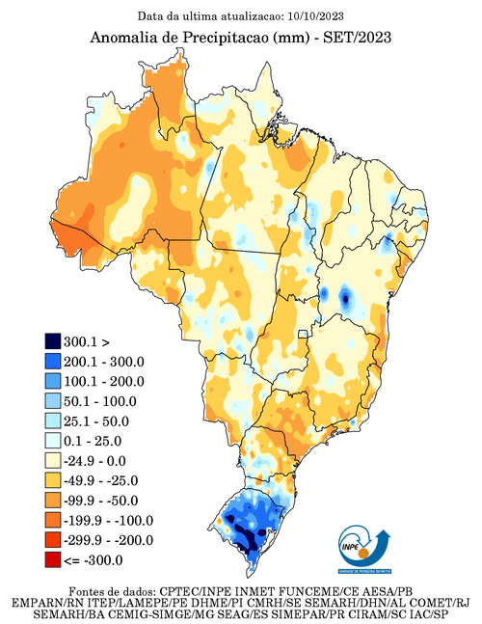

**Source:** <http://clima1.cptec.inpe.br/monitoramentobrasil/pt>

**2) Sea Surface Temperature (SST) anomalies**

The North Atlantic remained much warmer in relation to the South Atlantic. Since July this year, a gradual increase in tropical Pacific ocean temperature has been observed, remaining in the moderate intensity category; however, this month, temperatures were recorded 1.5°C above the historical average, indicating a possible evolution towards a more intense classification of the El Niño phenomenon.

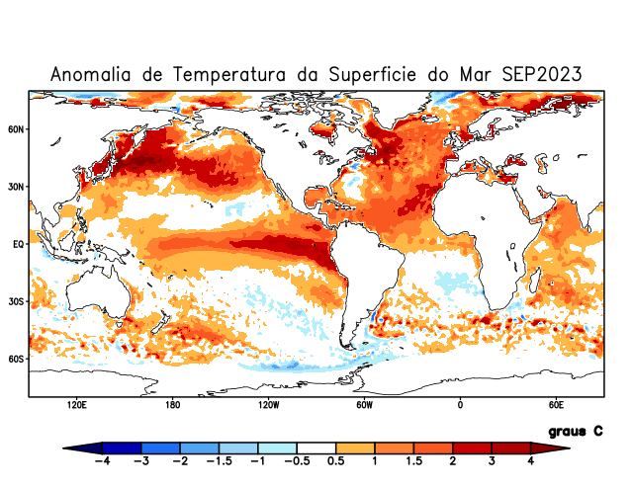

Source: <http://clima1.cptec.inpe.br/monitoramentoglobal/pt>

**3) Wind anomalies at 200 mb**

It is possible to verify the presence of an anticyclonic anomaly over the southeast of South America and a strong polar jet stream around 40ºS.

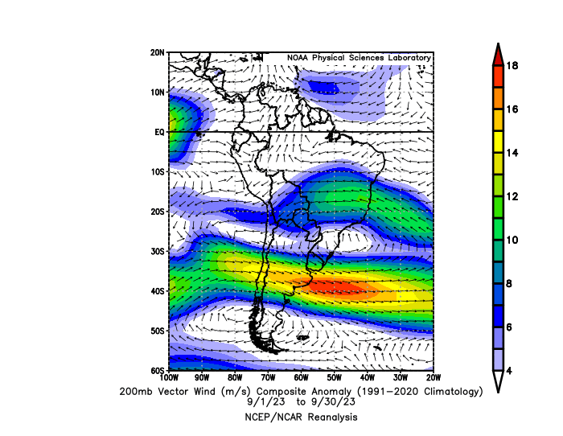

[**https://psl.noaa.gov/data/composites/day/**](https://psl.noaa.gov/data/composites/day/)

**4) Wind anomalies at 850 mb**

At 850 mb, it is possible to note an intense low-level jet from Amazon region towards south of Brazil, explaining the rainfall amounts seen in Rio Grande do Sul state due to the moisture transport from Amazon, which is known as an atmospheric river.

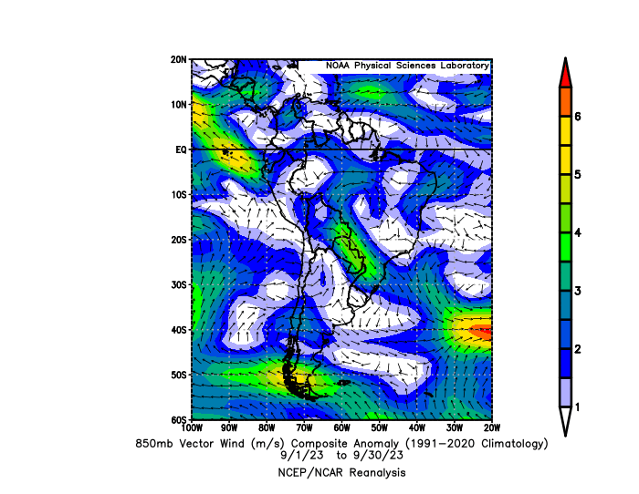

<https://psl.noaa.gov/data/composites/day/>