**Bulletin September 2022**

**1) Precipitation anomalies**

In September, positive precipitation anomalies were recorded mainly over the extreme north of Brazil and between the states of Paraná, Mato Grosso do Sul and São Paulo. Unlike previous months, in September the central region presented moderate amounts of rain in some regions. In the northern region, the largest amounts of rainfall were in the state of Roraima and northwestern and south of Pará state. In the Southeast Region, a greater rainfall amounts are noted over the south part of this region and mainly over São Paulo and Rio de Janeiro. The greater positive anomalies are seen in Parana and the greater negative anomalies are noted over Rio Grande do Sul state and southwestern of Amazonia region.

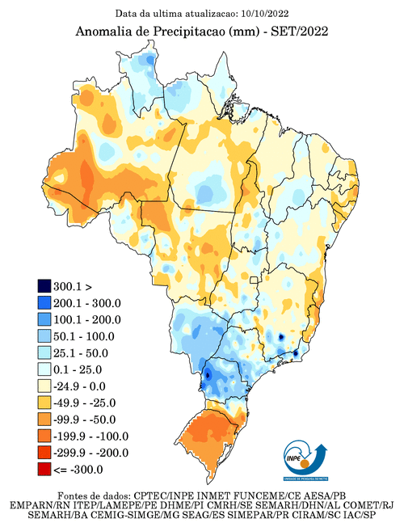

**Source:** <http://clima1.cptec.inpe.br/monitoramentoglobal/pt>

[https://portal.inmet.gov.br/boletinsagro#](https://portal.inmet.gov.br/boletinsagro)

**2) Sea Surface Temperature (SST) anomalies**

The North and southern South Atlantic regions were warm and had high anomaly values in September. Thus, the rainfall in the north of Brazil was favored by the positive SST anomalies. The La Ninã phenomena, which started in October 2021, still persists and so, the spring of 2022 will be the third with the La Niña acting, bringing concern for agriculture in southern Brazil.

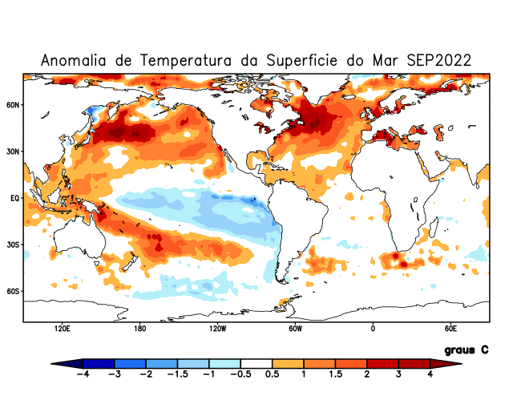

**Source:** <http://clima1.cptec.inpe.br/monitoramentoglobal/pt>

[https://portal.inmet.gov.br/boletinsagro#](https://portal.inmet.gov.br/boletinsagro)

**3) Wind anomalies at 200 mb**

High anomaly wind values are seen over La Plata basin and a strong subtropical jet stream is clearly seen around 20-25ºS. The subtropical jet stream acts like a natural atmospheric barrier, limiting how far cold fronts can reach. This condition in September could explain the negative precipitation anomalies in the Rio Grande do Sul state.

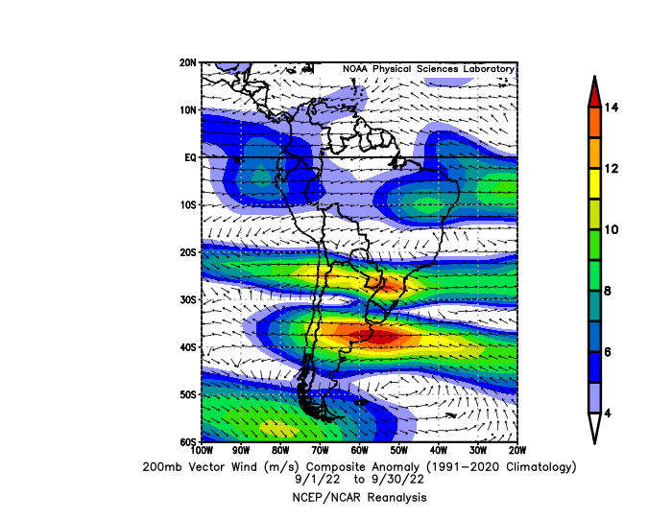

**Source:** [**https://psl.noaa.gov/data/composites/day/**](https://psl.noaa.gov/data/composites/day/)

**4) Wind anomalies at 850 mb**

At 850mb, low anomaly values ​are seen ​over the entire continent of South America. High anomaly values ​​are seen only over the South Pacific. A cyclonic anomaly, with its center over Paraguay, is seen and could explain the positive precipitation anomalies observed in Parana state.

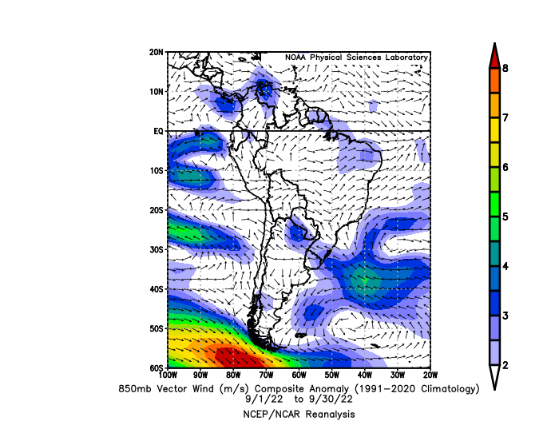

**Source:** [**https://psl.noaa.gov/data/composites/day/**](https://psl.noaa.gov/data/composites/day/)